Variogram Analysis

I. Empirical Variograms

Figure a) is an empirical variogram showing spatial correlation, because the smaller the lag distance (the distance between the locations for two comparable houses) the less variability in selling prices. Figure b) shows temporal correlation because the smaller the time lag or time difference between sales, the more similar the selling prices for the two comparable houses.

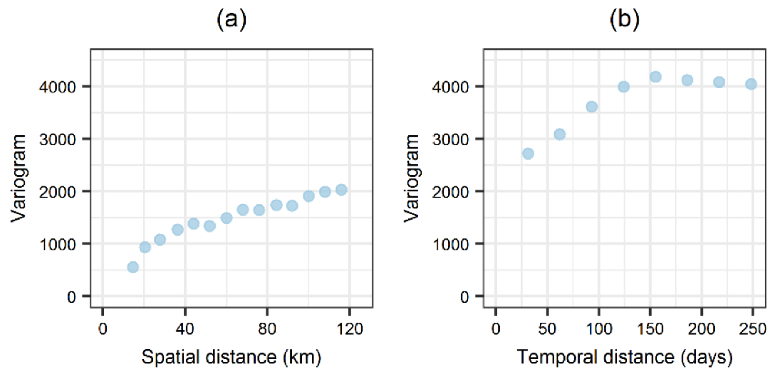

Source: Medeiros, Elias S.d., Renato R. de Lima, Ricardo A.d. Olinda, Leydson G. Dantas, and Carlos A.C.d. Santos. 2019. "Space–Time Kriging of Precipitation: Modeling the Large-Scale Variation with Model GAMLSS" Water 11, no. 11: 2368. <https://doi.org/10.3390/w11112368> . Figure 7.

II. Empirical Spatial Variogram with fitted Theoretical Variogram

Below find an empirical variogram that exhibits spatial correlation. A theoretical variogram (the line, below) is fit to the empirical variogram. The most common types of theoretical variogram models include: Exponential, Spherical, Matern and Linear.

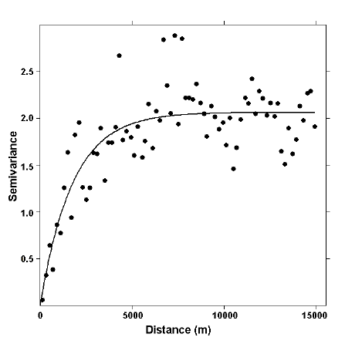

Source: <https://www.researchgate.net/figure/Empirical-variogram-dots-and-variogram-model-line-of-the-de-trended-juniper-density_fig2_228883082>

III. Empirical Temporal Variogram with corresponding Correlation function

Below find a theoretical temporal variogram model, labeled in blue as gamma(h) = γ(h), with corresponding theoretical correlation function or correlogram, labeled in red as C(h), that shows the correlation dropping off to zero (in red) as the time lag, h, between sales increases. Correspondingly, the variability in selling prices (in blue) increases as the lag time increases.

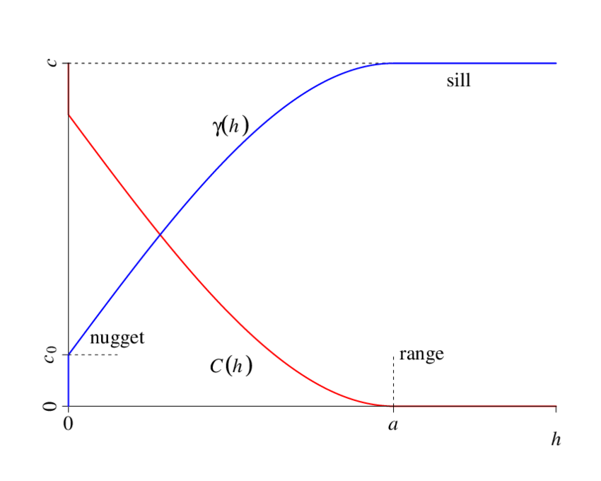

Source: Tolosana-Delgado, Raimon. (2022). Geostatistics for Constrained Variables: Positive Data, Compositions and Probabilities. Application to Environmental Hazard Monitoring. Available at: <https://www.researchgate.net/publication/265324282_GEOSTATISTICS_FOR_CONSTRAINED_VARIABLES_POSITIVE_DATA_COMPOSITIONS_AND_PROBABILITIES_APPLICATION_TO_ENVIRONMENTAL_HAZARD_MONITORING/stats> . Figure 3.1.

IV. Variogram Model Parameters

This next graph shows the parameters of the theoretical variogram of Range, Sill and Nugget fit to the empirical variogram. In general, the variogram or Geostatistical parameters (the range, sill and nugget) are estimated by maximum likelihood techniques, including Bayesian inference, so that all model parameters, including the (partial) slopes from a hedonic regression and the Geostatistical model parameters of range, sill and nugget, are estimated simultaneously. Rosburg et al. (2017) and Isakson and Ecker (2018) discuss simultaneously fitting a Geostatistical model and a regression, using SAS, for housing sales.

Source: <https://wiki.landscapetoolbox.org/doku.php/spatial_analysis_methods:semivariogram_analysis>

V. References - for more information see:

Spatial Variogram Models:

1. Cressie, Noel. 1993. *Statistic for Spatial Data*, John Wiley & Sons, Chapter 2
2. Ecker, Mark. 2003. Geostatistics: Past, Present and Future. In: *Encyclopedia of Life Support Systems (EOLSS),* Developed under the Auspices of the UNESCO, EOLSS Publishers, Oxford, U.K. Available at [www.eolss.net](http://www.eolss.net) and <https://www.eolss.net/sample-chapters/c02/E4-26-02-01.pdf> .
3. <https://www.youtube.com/watch?v=OxjrnVHO64c>

Temporal and Spatio-Temporal Variogram Models:

Diggle, Peter, Patrick Heagerty, Kung-Yee Liang, and Scott Zeger. 2002. *Analysis of Data.* Oxford University Press. Chapter 5.

Pebesma, Edzer and Benedikt Gr ̈aler. 2022. Introduction to spatio-temporal variography. Institute for Geoinformatics University of Münster. Available at <https://cran.rapporter.net/web/packages/gstat/vignettes/st.pdf> .

Variogram Model Fitting (using housing sales)

1. Isakson, Hans and Mark Ecker. 2018. "The Influence of Leaking Underground Storage Tanks on Nearby House Values." *Journal of Economic Insight.*  44, no. 1: 45-67.
2. Rosburg, Alicia, Hans Isakson, Mark Ecker, and Tim Strauss. 2017. “Beyond Standardized Test Scores: The Impact of a Public School Closure on House Prices.” *Journal of Housing Research* 26, no. 2: 119-135.